Money Minds has gone online
And we need YOUR help #moneyminds
Our employability and financial support for young people has just gone digital, with the launch of our free Money Minds website. It aims to help 11-to 19-year-olds to feel more confident about their finances and prepare for the world of work. The activities on the website are interactive and include topics like budgeting and what employers want.
The site is aimed at young people, as well as teachers, parents and carers and has something for everyone, from quick 15 minute games to full-length curriculum-linked lessons. We want the Money Minds website to be used by all, and our ambition is to reach 55,000 people through the platform by the end of 2022.

Help us inspire young people to be empowered and in control of their financial future.
Currently, only 48% of young people receive meaningful financial education and only 12% feel they have had support to understand the labour market and salary expectations.
Can you help us better equip young people to handle their financial affairs as they enter adulthood? We need you to shout out about YBS’s new Money Minds site! You can support in the following ways:
- Use the online resources and tools with the young people in your life
- Share the platform with your friends, family, teachers or carers
- Talk to customers in-branch about the new platform (further guidance will be shared with the retail network through the usual channels)
- Get involved with the #moneyminds social media campaign
#moneyminds
We want Money Minds online to reach far and wide to ensure we have the most significant impact possible. We need your help encouraging your friends, family and anyone you know to use the Money Minds website. All you have to do is click the social media platform’s logo and share the YBS post. If you want to add your own message, please use the provided social copy*.

Helping financial wellbeing happen
At YBS, we're here to help people achieve greater financial wellbeing and know that knowledge and understanding of managing money are essential to enabling healthy financial habits. This goes hand in hand with preparing young people for the world of work, as employment plays a big part in maintaining long term financial wellbeing.
Since 2015, the in-classroom Money Minds & Career Minds programme has supported 35,000 young people to gain the skills and knowledge they need to manage money and get ready for the world of work.. The digital expansion of the programme will enable us to increase the scale and impact of Money Minds we can make.

100% of teachers said they would recommend the site.
The new Money Minds website was designed in collaboration with teachers to help us ensure that we are reaching 11-19-year-olds in a learning style that benefits them. This is something new and will enable us to support young people throughout their school years. We are proud of what has been produced and what's better is the positive feedback we have received so far:
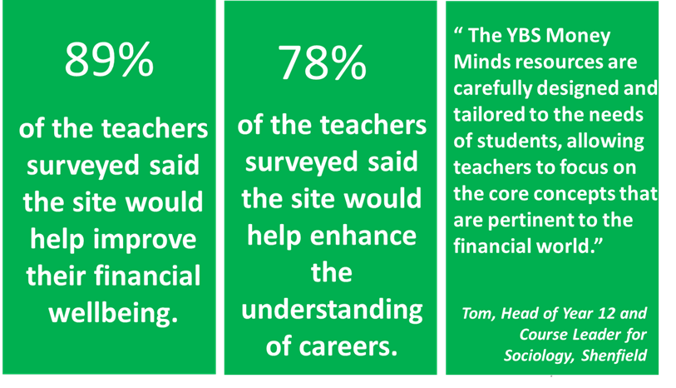
You may think you have heard about this before but under a different name. We softly launched the site with colleagues and our partner schools under the name Future Minds in November. But after facing some licencing difficulties under the original title, we reflected on the platform's goal and decided to bring the site under the Money Minds banner to enable us to build on the fantastic established programme.
If you have any questions or feedback about the site, please feel free to contact Community Team at Community@ybs.co.uk
*Facebook, Instagram, Linkedin: Excited to share Money Minds, a fantastic free resource from @yorkshirebuildingsociety created alongside students & teachers. Packed with games, videos, lesson plans & teaching materials for students from Key Stage 3 - 5 to get them talking about finances. #moneyminds
*Twitter: Excited to share Money Minds, a fantastic free resource from @yorkshire_BS created alongside students & teachers to help students from Key Stage 3 - 5 get talking about finances. #moneyminds

